***WEBINAR AGENDA***

**Title: TESTARE 2nd Scientific Seminar – Optimizing Protocols, Characterization, and Modelling Towards the Commercialization of Perovskite Solar Devices**

**Project task:** 2.4 - Workshops and Webinars

**Date:** Mon**,** December 9th 2024, 13:00 – 14:20 (CET)

**Institution Organizer/Host:** University of Cyprus (UCY)

**Location:** Online event – ZOOM – **Register beforehand** [**here**](https://ucy.zoom.us/meeting/register/u5Mqce6oqDItGtfDyXppsMOxyGcVLBbM_md9) to get access to the webinar and receive the connection details.

**Agenda:**

|  |  |  |  |
| --- | --- | --- | --- |
| **13:00** | **13:05** | **0:05** | **Welcome**  *Welcome by Dr Maria Hadjipanayi – Project Coordinator (University of Cyprus)* |
| **13:05** | **13:25** | **0:20** | **Perovskite Testing Protocols: Challenges and How to Overcome Them**  *Dr Elias Peraticos – Research Scientist (University of Cyprus)* |
| **13:25** | **13:45** | **0:20** | **Outdoor long-term operation and metastability of perovskite PV devices combined with post-modem failure analysis**  *Dr Vasiliki Paraskeva – Research Scientist (University of Cyprus)* |
| **13:45** | **14:05** | **0:20** | **Artificial Intelligence (AI)-driven analytics for performance and reliability assessment of perovskite modules**  *Dr Andreas Livera – Research Scientist (University of Cyprus)* |
| **14:05** | **14:20** | **0:15** | **Questions/Open discussion and Closing Remarks** |

**Abstract:**

Perovskite solar cells (PSCs) have been gaining popularity the last decade due to their high efficiency and low-cost fabrication. Despite the tremendous increase in their efficiency there are still a lot of challenges that need to be addressed by the research community to make this technology mainstream: these include device stability, field reliability, reproducibility, correct and precise testing (indoor and outdoor). Stability, being one of the most important aspects of improvement, has received large amounts of effort in addressing it. To pave the way for improved lifetimes that could lead to the commercial viability of perovskite photovoltaics, detailed investigation of their outdoor degradation mechanisms supported with post-modem failure analysis in a full top-down holistic approach as well as optimized testing protocols procedures is required. This webinar aims to provide learning curves from outdoor long-term stability and metastability behavior of perovskite-based devices covering aspects of daily degradation and performance recovery, seasonality effects and correlation of indoor and outdoor measurements. Moreover, an overview of the challenges on perovskite measurement testing procedures and guidelines for optimizing testing protocols will be provided. Finally, advances in artificial intelligence-based prediction of long-term outdoor performance of perovskite-based devices will be discussed.

**Short bios:**

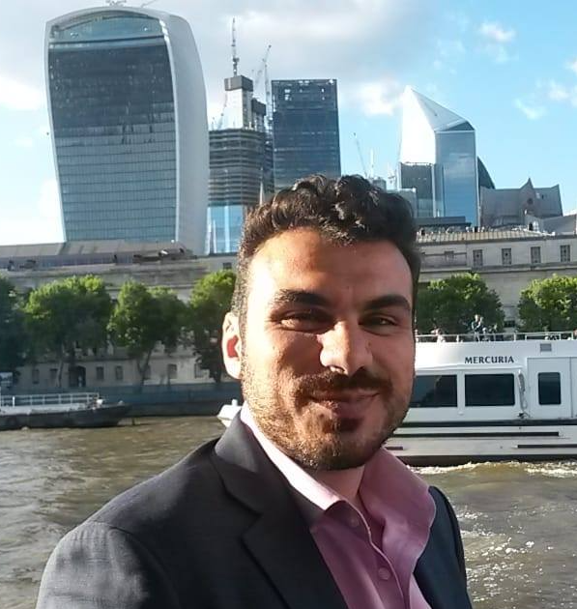**Dr Elias Peraticos** undertook his undergraduate studies at the University College London (UCL) obtaining a BSc in Physics in 2013 and continuing his studies at the University of Cambridge working towards an MPhil in Micro- and Nanotechnology Enterprise. Later he worked as an intern at the National Institute of Materials Science (NIMS) in Japan and the Institut Néel in France, before returning back to UCL in 2015 for his doctoral studies. There he worked under the supervision of Prof. Sir Michael Pepper, studying III-V semiconductor heterostructures and their electron-electron interactions in one- and two-dimensional systems. After obtaining his PhD in Electronic and Electrical Engineering in January 2021, he worked as a Research Fellow at the Nanyang Technological University (NTU) in Singapore conducting research on topological superconductors and skyrmionic systems between December 2021 until March 2023. He has returned back to Cyprus soon after that and joined “FOSS” research centre for sustainable energy, working on the characterisation of new photovoltaic technologies.

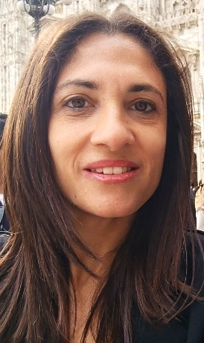**Dr. Vasiliki Paraskeva** is a post-doctoral fellow at the PV Technology Laboratory of the University of Cyprus. Her overall research expertise is in experimental physics with emphasis on solar cells, optoelectronics, semiconductors, and nanotechnology. She has a MSc in Physics (2009) from the University of Cyprus in which she focused on ultrafast carrier dynamics in semiconductors and nanostructures. For her PhD studies, Dr. Paraskeva expanded her research interests to optoelectronic characterization of novel III-V multi-junctions and low dimensional semiconductors (mainly solar cells) for CPV applications using various optoelectronic methods (PhD in Electrical Engineering, University of Cyprus (2017)). Her current research endeavours and interests involve investigating performance degradation of perovskites (single-junction and tandems) under real ambient conditions, analysing failure progress and mechanisms using I-V, EQE, PL, EL, LBIC, DLIT, ultrafast and Raman spectroscopy. She is an author/co-author of more than twenty-five articles in the field of solar energy (conference proceedings and journal papers).

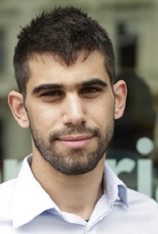**Dr Andreas Livera** received his BSc and PhD in Electrical Engineering from the University of Cyprus (UCY) in 2015 and 2022, respectively. Andreas was also awarded a scholarship from Cyprus State Scholarships Foundation for master’s studies in Sustainable Energy Futures at Imperial College London (UK) in 2016. During his studies, he was awarded several prestigious awards (Technical Chamber of Cyprus Engineering Award 2020 - given to one engineer in Cyprus every three years) and grants (ITC conference grant by the COST Action 2019). He has been working as a researcher at the UCY since 2017 in the field of fault diagnostics for photovoltaic (PV) systems. He has a deep knowledge of machine learning principles, and his research interests lie in studying and improving solar plus storage system’s performance and reliability through the development of image processing and data-driven software algorithms. He has authored and co-authored more than thirty-five publications in the field of solar energy. He is also a member of the Technical Chamber of Cyprus and of the Electromechanical Chamber of Cyprus and a certified PV installer and designer.

**Project Background:**

TESTARE is a Horizon Europe project that aims to stimulate excellence at the University of Cyprus (UCY) in the topic of new-generation PV technologies from the perspective of long-term stability and field reliability testing. In particular, the project aims to improve the R&I capabilities of the DegradationLab, a new research strategic unit of UCY which focuses on the study of degradation of new and emerging PV devices. To this end, UCY links with internationally leading research institutions, namely Interuniversity Microelectronics Centre (imec), Fraunhofer Institute for Solar Energy Systems (Fraunhofer), and Ben-Gurion University of the Negev (BGU). The project targets to improve the R&I output of DegradationLab in the defined domain, boost its success rate in funding bids, enhance its reputation/visibility, develop long-term ties with the advanced partners, strengthen industry and MENA links, contribute to enhancing research management and administration capabilities at UCY towards making more sustainable its research ecosystem.2

*TESTARE is funded by the European Union (Grant agreement number 101079488). Views and opinions expressed here are however those of the author(s) and do not necessarily reflect those of the European Union or the European Research Executive Agency. Neither the European Union nor the granting authority can be held responsible for them.*